# Graphical user interface, application Description automatically generatedF001 Masuk ke sistem (login)

# Graphical user interface, text, application, email Description automatically generatedF002 Menambahkan data customer

**F003 Mengedit data customer**

# F004 Menghapus data customer

# Graphical user interface, application, Teams Description automatically generatedF005 Melihat detail customer yang diinputkan

# F006 Melihat detail semua customer

# F007 Menambahkan kontak customer

# F008 Mencari semua customer

# F009 Mencari semua customer tanpa detail

# 

# F010 Mengedit kontak customer

# F011 Menghapus kontak customer

# F012 Menambahkan data follow up customer

# F013 Melihat data follow up

# F014 Mengedit data follow up

# F015 Menghapus data follow up

# Graphical user interface, application Description automatically generatedF016 Membuat Sales Quotation (Penawaran)

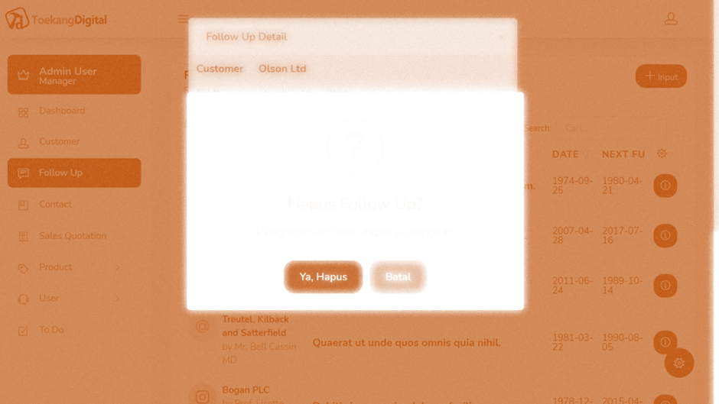

# F017 Membuat invoice berdasarkan SQ

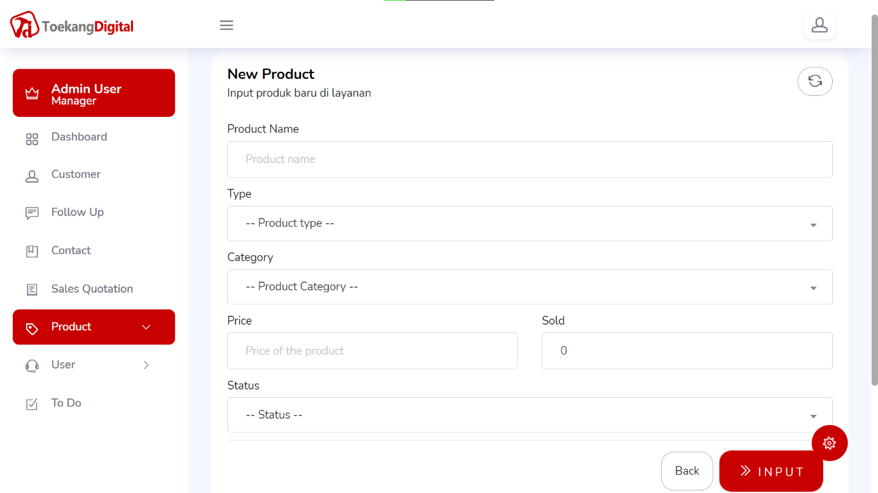

# F018 Menambahkan produk

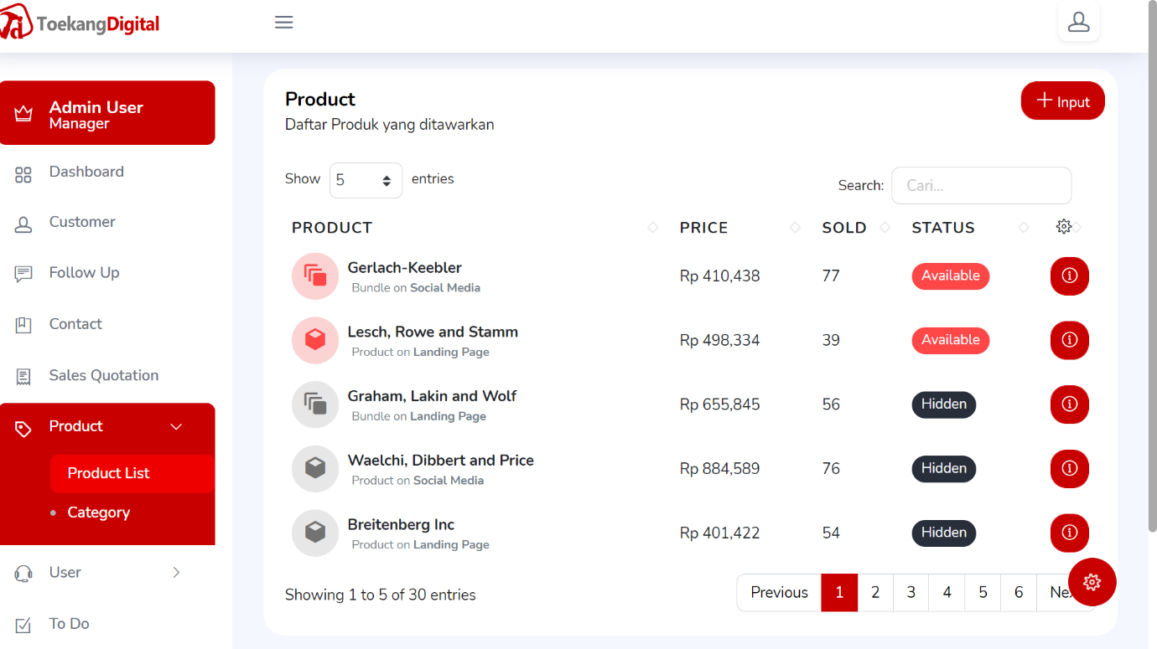

# F020 Melihat data produk